System to be build: Student Enroll Course System

Functional Requirement:-

1. *Login page*

Purpose: to allow students to login with their student Id & Password

1. *Student enroll courses*

Purpose: to allow students to register for the courses (registered courses will be store in to database)

1. *Courses CRUD*

Purpose: to manage every course in the database

1. Create new course
2. View Course Details
3. Edit Course Details
4. Delete Course (Maybe will just deactivate the course)

Work flow:-

1. Database
2. Courses CRUD
3. Student enroll courses
4. Login page

UML:-

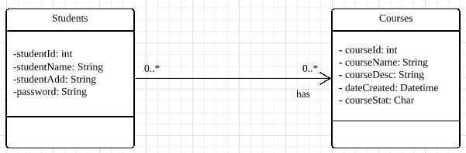

Database:-

JDBC connectivity with java DB

(later will change to JPA)